Registration Form:

Catechesis of the Good Shepherd Level I, Part II

Name: __________________________

Phone: ( ) _____________________

Address: ________________________

City/State/Zip: ____________________

E-Mail: __________________________

Parish: __________________________

Tuition: $350, Level 1 Part 2
Registration form and payment in full due September. 20, 2025

Make check payable to:
Epiphany of the Lord Catholic Community
MEMO: CGS Formation

Mail to:
ATTN: Charlotte Fulton
Epiphany of the Lord Catholic Community
1530 Norwalk Dr.
Katy, TX 77450

OR

Scan QR code below to complete registration and make payment online


WHAT IS THE CATECHESIS OF THE
GOOD SHEPHERD?

Catechesis of the Good Shepherd is an experiential approach to the spiritual formation of children 3-12 years of age.

Developed in 1954 by Hebrew scholar and theologian, Dr. Sofia Cavaletti and Montessori trainer, Gianna Gobbi, the Catechesis recognizes the existing relationship between God and the child and aims to nurture this relationship by helping the child “come close to God all by myself.”

In 1984, the Association of the Catechesis of the Good Shepherd was formed in North America.

Based on Montessori principles, the Catechesis introduces the child to the Scripture and the Liturgy through hands-on materials. These materials free the child to contemplate his/her own relationship with God and the Church. The catechist and the child are co-learners, seeking together the mystery of God and God’s Kingdom.

………….

"Let the children come to me and do not hinder them, for of such is the kingdom of God” Matthew 19:14

Catechesis
of the
Good Shepherd

Listening to God with Children
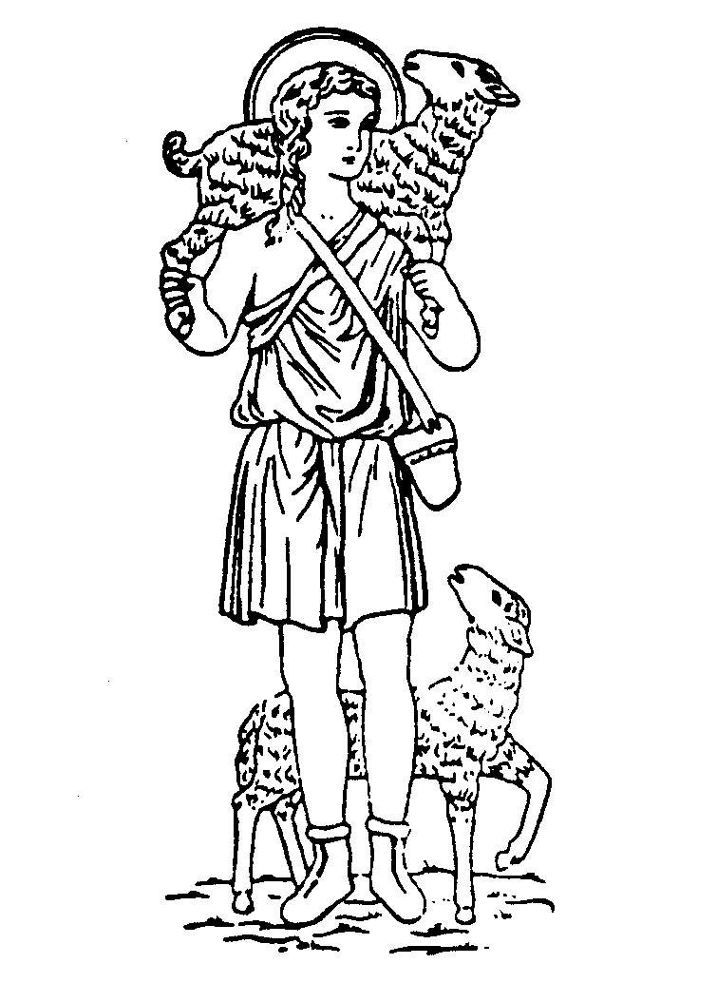

A Formation Course for Catechists

of Children 3 to 6 Years Old

Level I, Part II

Once a month on Saturdays
Start date:
Saturday, September 20, 2025

Epiphany of the Lord Catholic Community
1530 Norwalk Dr.
Katy, TX 77450

FORMATION COURSE
OBJECTlVES

• To present the methodology and guiding
principles of the Catechesis of the Good
Shepherd for the 3- to 6-year-old child while
preparing for work with older children

• To explore the religious nature and
most vital religious needs of the 3- to 6-year-
old child

• To meditate on the Biblical and Liturgical
themes presented to the 3- to 6-year-old child

• To broaden one’s ability to observe and
learn from the child, to listen to the
Scripture with the child, to deepen one’s
own enjoyment of God

• To offer guidelines and assistance in
preparing the 3 to 6 Atrium environment
and in making the catechist’s album and
catechetical materials

CERTIFICATION

The Association of the Catechesis of the Good Shepherd offers certification for Level I after completion of Part I (this course) and Part II: 90 hours total. Tuition includes the certification fee.

COMPLETE COURSE

Ages 3-6 Ages 6-9 Ages 9-12
Level I Part 1 Level II Part 1 Level III Part 1
*Level I Part 2 Level II Part 2 Level III Part 2

*This course (45 hours)

Level 1 is the foundation level training for the catechesis and is a prerequisite for the other levels.

FORMATION LEADER:

Jena Bissaillon has been involved with the Catechesis of the Good Shepherd for the past 18 years. As a trained catechist in all three levels, she introduced the Catechesis of the Good Shepherd to the West Houston area in 2011. In 2012, she opened and coordinated the atria at St. Bartholomew the Apostle Catholic Church of Katy TX which serve children from age 3 to age 12 and continued as Atrium Coordinator there for 7 years. She introduced the Catechesis of the Good Shepherd to her home parish Epiphany of the Lord Catholic Community of Katy TX in 2021, where she now serves as Atrium Coordinator for 2 levels of Catechesis which serve children from age 3 to age 9. She is married and has 3 grown children.

Level I, Part II 2025-26 Formation Dates:

Saturdays
2025: Sep 20, Oct 11, Nov 8
2026: Jan 17, Jan 31, Feb 21, Mar 28

SCHEDULE:
9:30 AM to 4:30 PM
Lunch and snacks will be provided each day.

LOCATION:


Epiphany of the Lord Catholic Community
1530 Norwalk Dr.
Katy, TX 77450

FINANCIAL AID:
Applications for financial aid may be requested through the CGS National Association at www.cgsusa.org. Catechists who plan to assist in the atrium at Epiphany of the Lord Catholic Community may request scholarship assistance by contacting:

Jena Bissaillon
281-546-2403
cgs@epiphanycatholic.org

